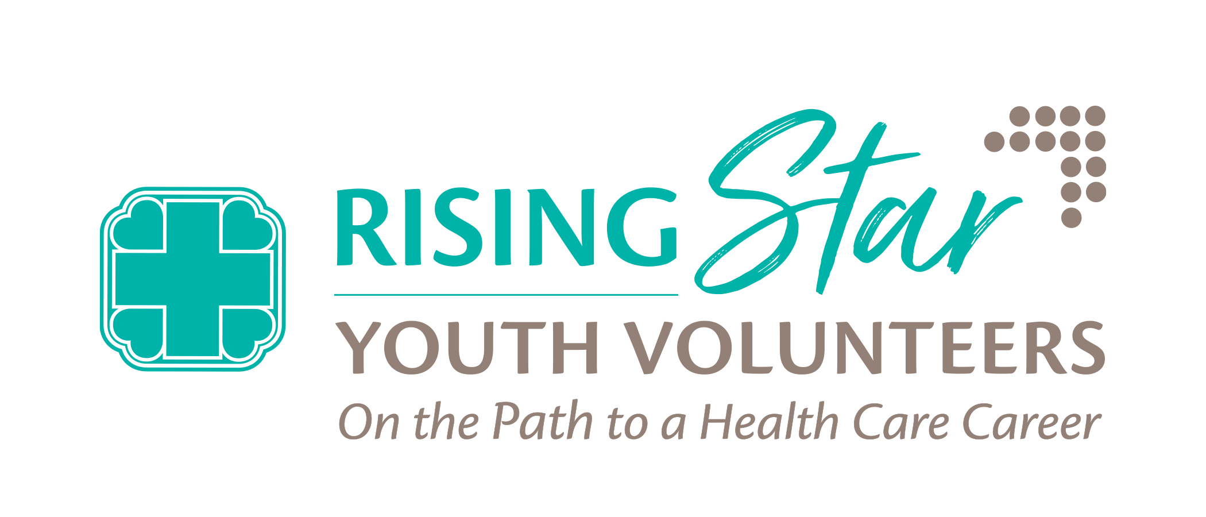
Rising Star Youth Volunteer Program Guidelines

- This is a competitive program with 16 available positions for each two-week session. Not all applicants will be selected.
- The applicant must be a currently enrolled in high school as a sophomore, junior or senior.
- The applicant must be 15 years old by June 8, 2026.
- The applicant must have a social security number. The social security number will be used to complete a background check.
- If accepted into the program, the applicant must provide vaccination records for Hepatitis B, MMR, Varicella and Tdap.

Session Dates:
- Session 1: June 8-19. 2026
- Session 2: July 6-17, 2026

Volunteer Hours:
- Monday - Thursday: 9:00 am - 3:00 pm
- Friday: 9:00 am - 12:30 pm
Application Process:

- Complete the online Rising Star Youth Volunteer Program Application
  - Must be completed by April 3, 2026
- Submit the Following Paperwork by April 3, 2026:
  - Two (2) online Rising Star Youth Volunteer Reference Forms submitted for the applicant
    - Must be completed by two different people who are not a relative to the applicant. References from a teacher, guidance counselor, employer, or leader of an organization the student is involved in are possible examples.
- Parent/Guardian Permission
  - Release of Liability
  - Confidentiality Statement
  - Background Authorization
  - Immunization Record
- Attend a group interview
  - Group interviews will be scheduled between April 20-April 30, 2026
IF SELECTED to the program, youth volunteers will be REQUIRED to:

- Submit all required Acceptance Paperwork by May 15, 2026
- Attend the Rising Star Youth Volunteer Orientation on June 2, 2026 (for those selected for Session 1) or June 23, 2026 (for those selected for Session 2)
  - During Orientation, youth volunteers will meet with Beaufort Memorial Hospital Employee Health to begin a PPD (tuberculosis) Skin Test. Youth Volunteers must have the PPD Skin test examined after 48-72 hours by designated Beaufort Memorial staff.
- Arrive on time and volunteer for the entire two-week program session
- Comply and follow all Beaufort Memorial policies, procedures and standards
- Wear a facemask while volunteering in designated areas

If you have any questions, please contact Kathy Bingham at Kathleen.bingham@bmhsc.org or 843-522-5835.

